***ATTRITION ASSIGNMENT***

*STEP 1 = LAUNCHING :*

*import pandas as p*

*import numpy as n*

*import matpolib.pyplot as pl*

*data=pd.read_csv(“general_data.csv”)*

*->To find column names .*

*data.columns*

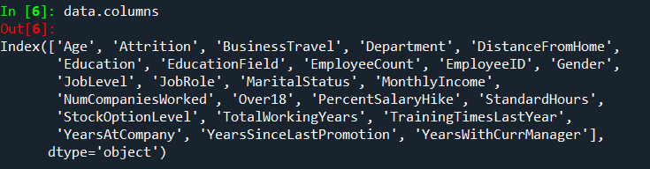

*->To find the data of first 5 rows.*

*data.head( )*

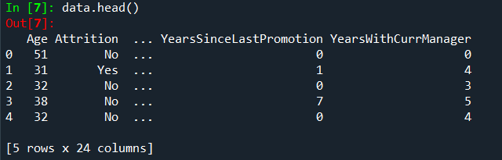

*STEP 2 = DATA TREATMENT :*

*->To find out null values in the table.*

*data.isnull( )*

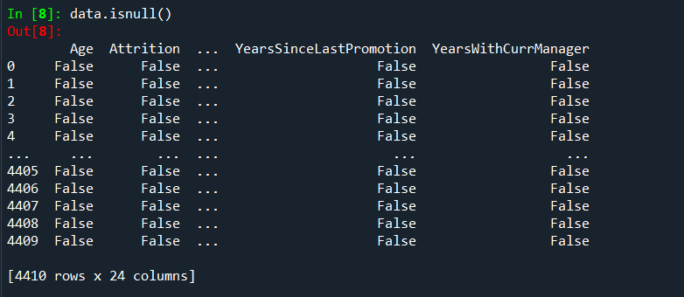

*->To find out duplicated values of table.*

*data.duplicated( )*

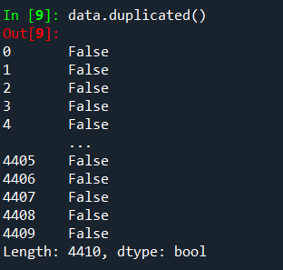

*->To drop all duplicated values of the table.*

*data.drop_duplicates( )*

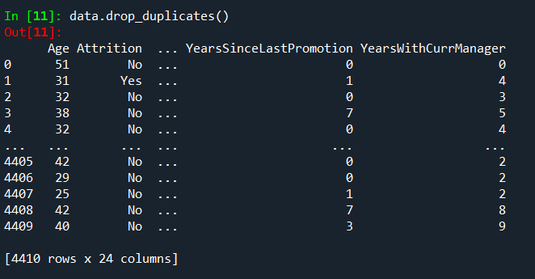

*STEP 3 = UNIVARIATE ANALYSIS :*

*->To describe the whole table.*

*data1=data[['Age', 'Attrition', 'BusinessTravel', 'Department', 'DistanceFromHome','Education', 'EducationField', 'EmployeeCount', 'EmployeeID', 'Gender','JobLevel', 'JobRole', 'MaritalStatus', 'MonthlyIncome', 'NumCompaniesWorked', 'Over18', 'PercentSalaryHike', 'StandardHours','StockOptionLevel', 'TotalWorkingYears', 'TrainingTimesLastYear','YearsAtCompany', 'YearsSinceLastPromotion', 'YearsWithCurrManager']].describe( )*

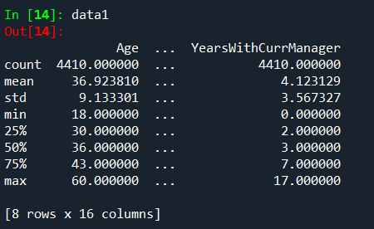

*->To find out median of each column .*

*data2=data[['Age', 'Attrition', 'BusinessTravel', 'Department', 'DistanceFromHome','Education', 'EducationField', 'EmployeeCount', 'EmployeeID', 'Gender','JobLevel', 'JobRole', 'MaritalStatus', 'MonthlyIncome', 'NumCompaniesWorked', 'Over18', 'PercentSalaryHike', 'StandardHours','StockOptionLevel', 'TotalWorkingYears', 'TrainingTimesLastYear','YearsAtCompany', 'YearsSinceLastPromotion', 'YearsWithCurrManager']].median( )*

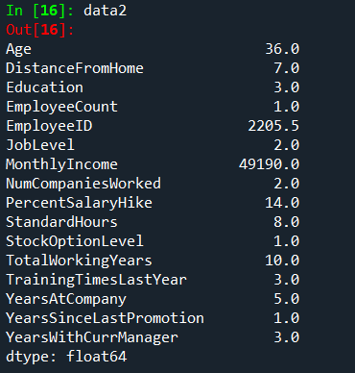

*->To find out mean of each column.*

*data3=data[['Age', 'Attrition', 'BusinessTravel', 'Department', 'DistanceFromHome','Education', 'EducationField', 'EmployeeCount', 'EmployeeID', 'Gender','JobLevel', 'JobRole', 'MaritalStatus', 'MonthlyIncome', 'NumCompaniesWorked', 'Over18', 'PercentSalaryHike', 'StandardHours','StockOptionLevel', 'TotalWorkingYears', 'TrainingTimesLastYear','YearsAtCompany', 'YearsSinceLastPromotion', 'YearsWithCurrManager']].mean( )*

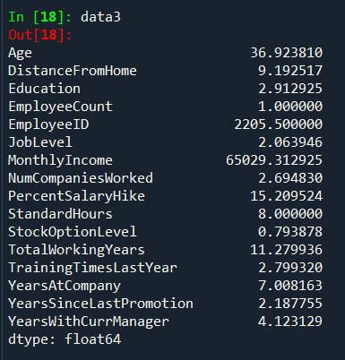

*->To find out mode.*

*data4=data[['Age', 'Attrition', 'BusinessTravel', 'Department', 'DistanceFromHome','Education', 'EducationField', 'EmployeeCount', 'EmployeeID', 'Gender','JobLevel', 'JobRole', 'MaritalStatus', 'MonthlyIncome', 'NumCompaniesWorked', 'Over18', 'PercentSalaryHike', 'StandardHours','StockOptionLevel', 'TotalWorkingYears', 'TrainingTimesLastYear','YearsAtCompany', 'YearsSinceLastPromotion', 'YearsWithCurrManager']].mode( )*

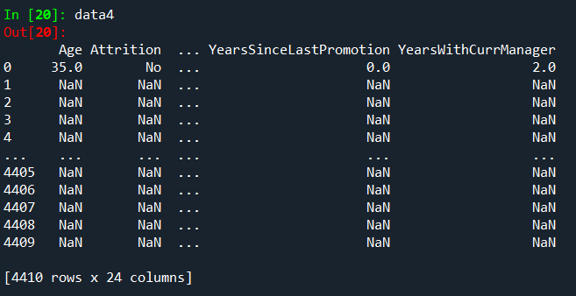

*->To find variance of each column.*

*data5=data[['Age', 'Attrition', 'BusinessTravel', 'Department', 'DistanceFromHome','Education', 'EducationField', 'EmployeeCount', 'EmployeeID', 'Gender','JobLevel', 'JobRole', 'MaritalStatus', 'MonthlyIncome', 'NumCompaniesWorked', 'Over18', 'PercentSalaryHike', 'StandardHours','StockOptionLevel', 'TotalWorkingYears', 'TrainingTimesLastYear','YearsAtCompany', 'YearsSinceLastPromotion', 'YearsWithCurrManager']].var( )*

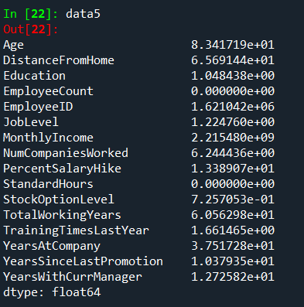

*->To find skewness.*

*data6=data[['Age', 'Attrition', 'BusinessTravel', 'Department', 'DistanceFromHome','Education', 'EducationField', 'EmployeeCount', 'EmployeeID', 'Gender','JobLevel', 'JobRole', 'MaritalStatus', 'MonthlyIncome', 'NumCompaniesWorked', 'Over18', 'PercentSalaryHike', 'StandardHours','StockOptionLevel', 'TotalWorkingYears', 'TrainingTimesLastYear','YearsAtCompany', 'YearsSinceLastPromotion', 'YearsWithCurrManager']].skew( )*

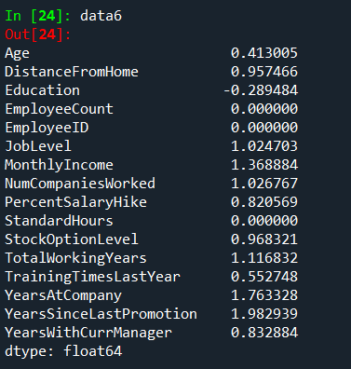

*->To find out kurtosis.*

*data7=data[['Age', 'Attrition', 'BusinessTravel', 'Department', 'DistanceFromHome','Education', 'EducationField', 'EmployeeCount', 'EmployeeID', 'Gender','JobLevel', 'JobRole', 'MaritalStatus', 'MonthlyIncome', 'NumCompaniesWorked', 'Over18', 'PercentSalaryHike', 'StandardHours','StockOptionLevel', 'TotalWorkingYears', 'TrainingTimesLastYear','YearsAtCompany', 'YearsSinceLastPromotion', 'YearsWithCurrManager']].kurt( )*

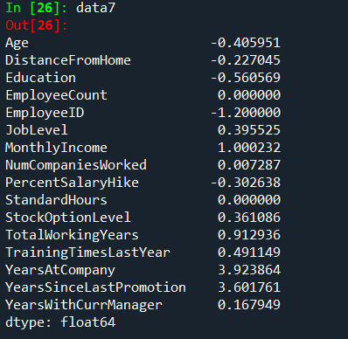

*->To find standard deviation .*

*data8=data[['Age', 'Attrition', 'BusinessTravel', 'Department', 'DistanceFromHome','Education', 'EducationField', 'EmployeeCount', 'EmployeeID', 'Gender','JobLevel', 'JobRole', 'MaritalStatus', 'MonthlyIncome', 'NumCompaniesWorked', 'Over18', 'PercentSalaryHike', 'StandardHours','StockOptionLevel', 'TotalWorkingYears', 'TrainingTimesLastYear','YearsAtCompany', 'YearsSinceLastPromotion', 'YearsWithCurrManager']].std( )*

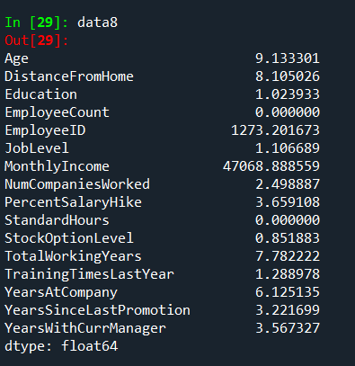

*INFERENCE :*

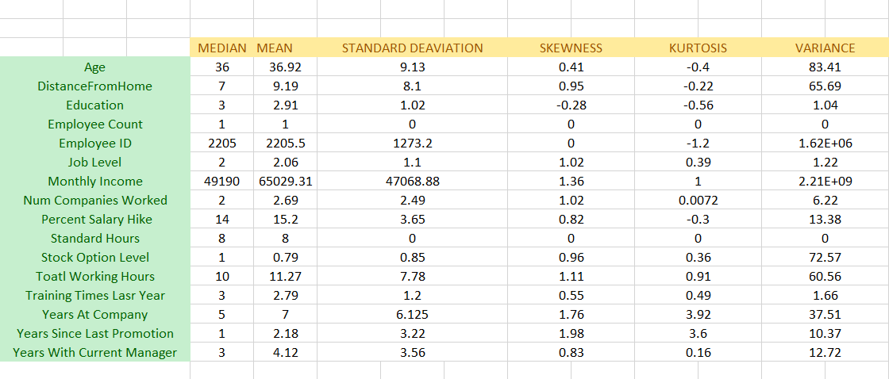

*->All the above variables show positive skewness; while Age &Mean_distance_from_home are leptokurtic and all other variables are platykurtic.*

*OUTLIERS :*

*There’s no regression found while plotting Age, MonthlyIncome, TotalWorkingYears , YearsAtCompany, etc., on a scatter plot.*

*box_plot=data.Age*

*pl.boxplot(box_plot)*

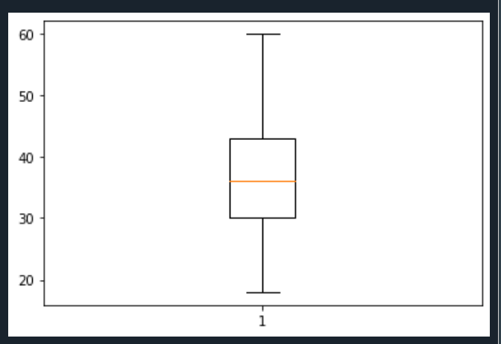

*Age is normally distributed without any outliers*

*box_plot=data.MonthlyIncome*

*pl.boxplot(box_plot)*

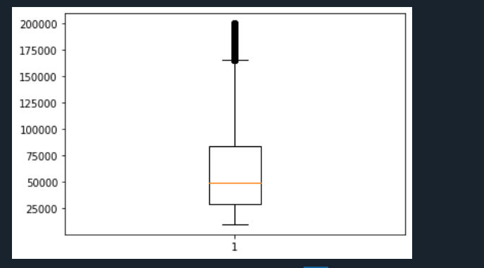

*Monthly Income is Right skewed with several outliers*

*box_plot=data.YearsAtCompany*

*pl.boxplot(box_plot)*

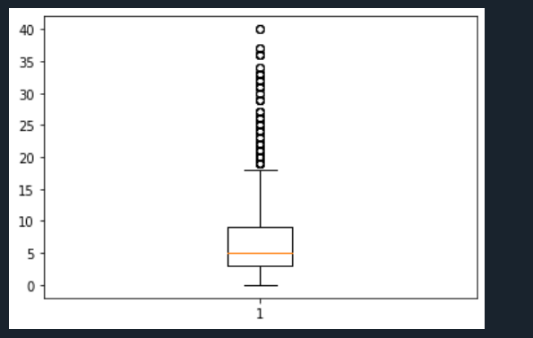

*Years at company is also Right Skewed with several outliers observed.*

*\*\*\*\*\*\**